Autonomous AI Agent Creator – Combined PRD

# Section 1: Original PRD

# Product Requirements Document: Autonomous AI Agent Creator  
  
## 1. Product Overview  
  
### 1.1 Product Vision  
Create an open-source, autonomous AI agent system that can discover, process, and convert various company knowledge sources into specialized AI agents with minimal human intervention. These agents will function as domain experts within a company chatbot, capable of handling both knowledge dissemination and workflow automation.  
  
### 1.2 Target Users  
- **Primary**: Product managers who need to create and manage AI chatbot agents for their companies  
- **Secondary**: Developers who want to extend or customize the platform  
- **Tertiary**: End users who interact with the created chatbot agents  
  
### 1.3 Key Value Propositions  
- **Autonomy**: Minimizes manual effort in creating specialized AI agents  
- **Flexibility**: Handles diverse knowledge sources and workflows  
- **Accessibility**: Easy to set up and use via Streamlit interface  
- **Transparency**: Provides visibility into agent creation and decision-making  
- **Adaptability**: Continuously improves through feedback loops  
  
## 2. System Architecture  
  
### 2.1 High-Level Architecture  
  
```mermaid  
graph TD  
 A[Autonomous Orchestrator Agent] --> B[Knowledge Discovery]  
 A --> C[Knowledge Processing]  
 A --> D[Agent Creation]  
 A --> E[Integration & Routing]  
 A --> F[Evaluation & Improvement]  
 A --> G[Workflow Automation]  
 A --> H[Human Intervention Interface]  
   
 B --> B1[Document Scanner]  
 B --> B2[Database Connector]  
 B --> B3[API Explorer]  
 B --> B4[Web Crawler]  
   
 C --> C1[Content Extraction]  
 C --> C2[Knowledge Structuring]  
 C --> C3[Embedding Generation]  
 C --> C4[Vector Storage]  
 C --> C5[History Retention]  
   
 D --> D1[Domain Classification]  
 D --> D2[Agent Template Selection]  
 D --> D3[Agent Configuration]  
 D --> D4[Agent Deployment]  
 D --> D5[Dynamic Agent Updates]  
   
 E --> E1[Topic Router]  
 E --> E2[Context Manager]  
 E --> E3[Response Synthesizer]  
   
 F --> F1[User Feedback Collection]  
 F --> F2[Performance Metrics]  
 F --> F3[Knowledge Gap Detection]  
 F --> F4[Agent Retraining]  
   
 G --> G1[API-to-Tool Conversion]  
 G --> G2[Workflow Definition]  
 G --> G3[Workflow Execution]  
 G --> G4[Workflow Monitoring]  
   
 H --> H1[Knowledge Source Review]  
 H --> H2[Agent Configuration Review]  
 H --> H3[Response Override]  
 H --> H4[Manual Retraining]  
```  
  
### 2.2 Framework Integration  
  
The system will leverage multiple agent frameworks to maximize autonomy and flexibility:  
  
- **LangChain/LlamaIndex**: Core orchestration and document processing  
- **CrewAI**: Multi-agent collaboration and task delegation  
- **MCP SDK**: Tool and resource management  
- **SmolaGents**: Lightweight, specialized agents for specific tasks  
- **Custom Components**: For unique requirements and integrations  
  
### 2.3 Data Flow  
  
```mermaid  
sequenceDiagram  
 participant PM as Product Manager  
 participant UI as Streamlit UI  
 participant OA as Orchestrator Agent  
 participant KS as Knowledge Sources  
 participant KP as Knowledge Processing  
 participant AC as Agent Creation  
 participant WA as Workflow Automation  
 participant CB as Chatbot Interface  
 participant EU as End User  
   
 PM->>UI: Provide LLM credentials  
 PM->>UI: Specify knowledge sources  
 UI->>OA: Initialize with credentials  
 OA->>KS: Discover and access sources  
 KS-->>OA: Return source content  
 OA->>KP: Process knowledge  
 KP->>KP: Extract, structure, embed  
 KP->>KP: Store with history tracking  
 KP-->>OA: Return processed knowledge  
 OA->>AC: Create specialized agents  
 AC->>AC: Classify domains  
 AC->>AC: Configure agent templates  
 AC->>AC: Deploy agents  
 PM->>UI: Specify workflow requirements  
 UI->>WA: Configure workflow automation  
 WA->>WA: Convert APIs to tools  
 WA->>WA: Define workflow steps  
 WA-->>AC: Integrate with agents  
 AC-->>OA: Register completed agents  
 PM->>UI: Test agents via chat  
 UI->>CB: Forward test queries  
 CB->>AC: Route to appropriate agent  
 AC-->>CB: Return agent responses  
 CB-->>UI: Display responses  
 PM->>UI: Provide feedback  
 UI->>OA: Forward feedback for improvement  
 EU->>CB: Real user queries  
 CB->>AC: Route to appropriate agent  
 AC-->>CB: Return agent responses  
 CB-->>EU: Display responses  
```  
  
## 3. Functional Requirements  
  
### 3.1 Streamlit User Interface  
  
#### 3.1.1 Authentication & Credentials  
- User registration and login system  
- Secure storage of LLM API credentials  
- Role-based access control  
  
#### 3.1.2 Knowledge Source Management  
- Interface to add, edit, and remove knowledge sources  
- Support for uploading documents  
- Configuration for database connections  
- URL inputs for web sources  
- API endpoint and documentation inputs  
  
#### 3.1.3 Agent Creation & Management  
- Dashboard showing all created agents  
- Agent creation wizard  
- Agent editing and configuration interface  
- Agent testing interface  
- Version history and rollback capabilities  
  
#### 3.1.4 Workflow Automation  
- Interface to define workflows  
- API configuration tool  
- Workflow testing and debugging tools  
- Workflow monitoring dashboard  
  
#### 3.1.5 Monitoring & Feedback  
- Performance metrics dashboard  
- User feedback collection interface  
- Knowledge gap visualization  
- System resource utilization monitoring  
- Audit logs viewer  
  
### 3.2 Autonomous Orchestrator Agent  
  
#### 3.2.1 Core Capabilities  
- Multi-framework agent orchestration  
- Decision-making for autonomous operations  
- Resource allocation and scheduling  
- Error handling and recovery  
- State management across operations  
  
#### 3.2.2 Human Intervention Points  
- Knowledge source review and approval  
- Agent configuration review and modification  
- Response override capabilities  
- Manual retraining triggers  
- System parameter adjustments  
  
### 3.3 Knowledge Discovery & Processing  
  
#### 3.3.1 Supported Knowledge Sources  
- Documents (PDF, DOCX, TXT, etc.)  
- Databases (SQL, NoSQL)  
- APIs (REST, GraphQL)  
- Websites and internal wikis  
- Structured data (CSV, JSON, XML)  
  
#### 3.3.2 Processing Capabilities  
- Multi-format content extraction  
- Intelligent chunking strategies  
- Embedding generation with model selection  
- Knowledge graph construction  
- Vector database management  
- History retention and versioning  
  
### 3.4 Agent Creation  
  
#### 3.4.1 Domain Classification  
- Automatic topic clustering  
- Domain boundary detection  
- Cross-domain relationship mapping  
- Domain priority determination  
  
#### 3.4.2 Agent Templates  
- Knowledge-based Q&A agents  
- Workflow automation agents  
- Multi-tool agents  
- Reasoning agents  
- Custom template creation  
  
#### 3.4.3 Dynamic Agent Management  
- Agent versioning  
- A/B testing of agent configurations  
- Agent performance monitoring  
- Automatic and manual agent updates  
  
### 3.5 Workflow Automation  
  
#### 3.5.1 API-to-Tool Conversion  
- API documentation parsing  
- Interactive API exploration  
- Automatic tool creation from APIs  
- Tool testing and validation  
  
#### 3.5.2 Workflow Definition  
- Step-by-step workflow creation  
- Conditional branching  
- Error handling and retries  
- Human-in-the-loop steps  
- Parallel processing  
  
#### 3.5.3 Workflow Execution  
- Scheduled workflows  
- Event-triggered workflows  
- Manual workflow execution  
- Workflow status tracking  
  
### 3.6 Evaluation & Improvement  
  
#### 3.6.1 Feedback Collection  
- Explicit user ratings  
- Implicit feedback analysis  
- Conversation analysis  
- Performance metrics tracking  
  
#### 3.6.2 Continuous Improvement  
- Automated retraining schedules  
- Knowledge gap identification  
- Agent behavior optimization  
- Workflow efficiency improvements  
  
## 4. Non-Functional Requirements  
  
### 4.1 Security  
  
#### 4.1.1 Authentication & Authorization  
- Secure user authentication  
- Role-based access control  
- API key management  
- Session management  
  
#### 4.1.2 Data Protection  
- Encryption at rest and in transit  
- Secure credential storage  
- Access logging and auditing  
- Data retention policies  
  
### 4.2 Performance  
  
#### 4.2.1 Scalability  
- Horizontal scaling for increased load  
- Efficient resource utilization  
- Caching strategies  
- Asynchronous processing  
  
#### 4.2.2 Response Times  
- Agent response time < 2 seconds for standard queries  
- Batch processing capabilities for large knowledge sources  
- Progress indicators for long-running operations  
  
### 4.3 Reliability  
  
#### 4.3.1 Error Handling  
- Graceful degradation  
- Comprehensive error logging  
- Automatic retry mechanisms  
- User-friendly error messages  
  
#### 4.3.2 Data Integrity  
- Knowledge source versioning  
- Agent configuration backups  
- Transaction management for critical operations  
  
### 4.4 Usability  
  
#### 4.4.1 User Interface  
- Intuitive, responsive design  
- Consistent navigation and interaction patterns  
- Helpful tooltips and documentation  
- Accessibility compliance  
  
#### 4.4.2 User Experience  
- Minimal setup requirements  
- Clear feedback on system status  
- Guided workflows for complex tasks  
- Comprehensive help resources  
  
## 5. Technical Specifications  
  
### 5.1 Technology Stack  
  
#### 5.1.1 Core Technologies  
- **Programming Language**: Python 3.9+  
- **LLM Integration**: OpenAI API, Anthropic API, local models via LlamaCPP  
- **Agent Frameworks**: LangChain, CrewAI, MCP SDK, SmolaGents  
- **Document Processing**: LlamaIndex, Unstructured.io  
- **Vector Database**: Chroma, FAISS, or Pinecone  
- **Knowledge Graph**: Neo4j or custom solution  
- **Frontend**: Streamlit  
- **API Layer**: FastAPI  
  
#### 5.1.2 Supporting Technologies  
- **Containerization**: Docker  
- **Version Control**: Git  
- **Testing**: Pytest, hypothesis  
- **CI/CD**: GitHub Actions  
- **Monitoring**: Prometheus + Grafana  
- **Logging**: ELK Stack or similar  
  
### 5.2 Deployment Options  
  
#### 5.2.1 Local Deployment  
- Docker Compose setup for local development and testing  
- Minimal resource requirements specification  
- Local model support for reduced API costs  
  
#### 5.2.2 Cloud Deployment  
- Deployment guides for major cloud providers  
- Infrastructure-as-Code templates  
- Scaling recommendations  
  
## 6. Implementation Plan  
  
### 6.1 Phase 1: Foundation (Weeks 1-4)  
- Repository setup with documentation  
- Streamlit UI basic structure  
- LLM credential management  
- Simple document processing pipeline  
- Basic agent creation with fixed templates  
- Initial testing framework  
  
### 6.2 Phase 2: Core Functionality (Weeks 5-8)  
- Multi-source knowledge processing  
- Advanced agent creation with domain classification  
- Basic workflow automation  
- Human intervention interfaces  
- Feedback collection system  
- Comprehensive testing suite  
  
### 6.3 Phase 3: Advanced Features (Weeks 9-12)  
- Multi-framework agent integration  
- Advanced workflow automation  
- Knowledge history and versioning  
- Dynamic agent updates  
- Performance optimization  
- Security hardening  
  
### 6.4 Phase 4: Refinement & Documentation (Weeks 13-16)  
- UI/UX improvements  
- Comprehensive documentation  
- Example templates and use cases  
- Community contribution guidelines  
- Final testing and bug fixes  
- Release preparation  
  
## 7. Success Metrics  
  
### 7.1 Technical Metrics  
- **Autonomy Rate**: Percentage of operations completed without human intervention  
- **Processing Efficiency**: Time to process knowledge sources of various sizes  
- **Agent Quality**: Accuracy of agent responses compared to ground truth  
- **System Reliability**: Uptime and error rates  
  
### 7.2 User Experience Metrics  
- **Setup Time**: Time required for new users to create their first agent  
- **User Satisfaction**: Feedback ratings from product managers  
- **Knowledge Coverage**: Percentage of user queries successfully answered  
- **Workflow Efficiency**: Time saved through automated workflows  
  
## 8. Risks and Mitigations  
  
| Risk | Impact | Likelihood | Mitigation Strategy |  
|------|--------|------------|---------------------|  
| LLM API limitations | High | Medium | Support multiple providers, implement rate limiting, add local model support |  
| Complex knowledge sources | Medium | High | Develop robust parsing strategies, provide clear error messages, allow manual corrections |  
| Security vulnerabilities | High | Low | Regular security audits, follow best practices, limit access to sensitive operations |  
| Poor agent performance | Medium | Medium | Implement comprehensive testing, feedback loops, and continuous improvement |  
| Resource constraints | Medium | Medium | Optimize resource usage, implement caching, provide deployment recommendations |  
  
## 9. Future Enhancements  
  
### 9.1 Short-term Enhancements  
- Additional LLM provider integrations  
- More document format support  
- Enhanced visualization of agent decision-making  
- Expanded workflow automation capabilities  
  
### 9.2 Long-term Vision  
- Multi-language support  
- Advanced reasoning capabilities  
- Collaborative agent networks  
- Integration with popular enterprise systems  
- Mobile companion app  
  
## 10. Appendices  
  
### 10.1 Glossary  
- **Agent**: An autonomous software entity that performs specific tasks  
- **Knowledge Source**: Any repository of information that can be processed by the system  
- **Workflow**: A sequence of operations that accomplish a specific business process  
- **Embedding**: Vector representation of text for semantic search and comparison  
- **LLM**: Large Language Model, the foundation of AI agents  
  
### 10.2 References  
- LangChain Documentation  
- CrewAI Documentation  
- MCP SDK Documentation  
- SmolaGents Documentation  
- Streamlit Documentation  
- Vector Database Best Practices

# Section 2: Enhancements from Iterative Design Discussion

The following features and design elements were collaboratively discussed and agreed upon. These build on the original vision of an AI system that autonomously creates chatbot agents for organizations:

* Addition of 'Chatbot Spaces' – scoped workspaces to manage one bot at a time.
* Streamlit-style UI design with three panels: Tools (left), Agent Builder Chat (center), Test Chatbot (right).
* ‘Full Scan’ tool for crawling websites, interacting with embedded chatbots, and generating domain knowledge.
* Agent Builder Chat enhanced to act as a progress dashboard, showing steps and asking clarification only when needed.
* Feedback loop integration: feedback from test chat triggers retraining and reflects progress in real time.
* Mock API Generator tool – allows the creation of static dummy APIs for rapid prototyping and demos.

# Section 3: Streamlit UI Design Visuals

Initial layout with Full Scan feature

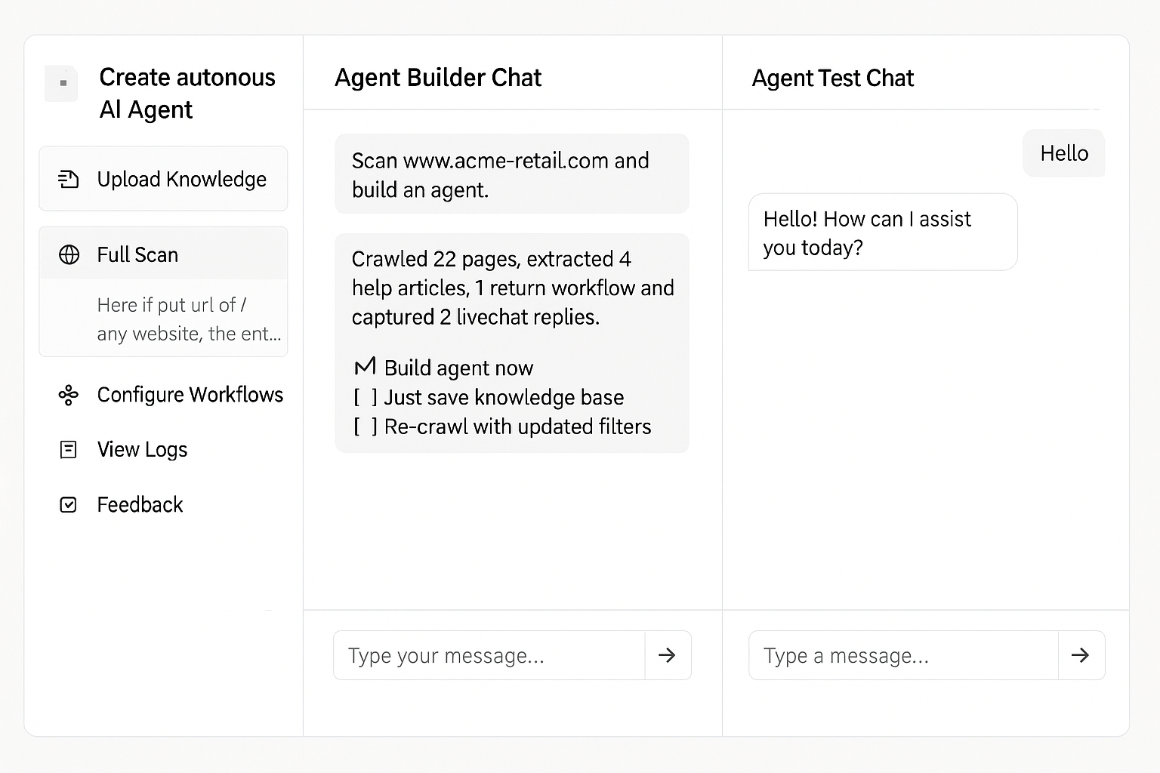

Chatbot Space selector added

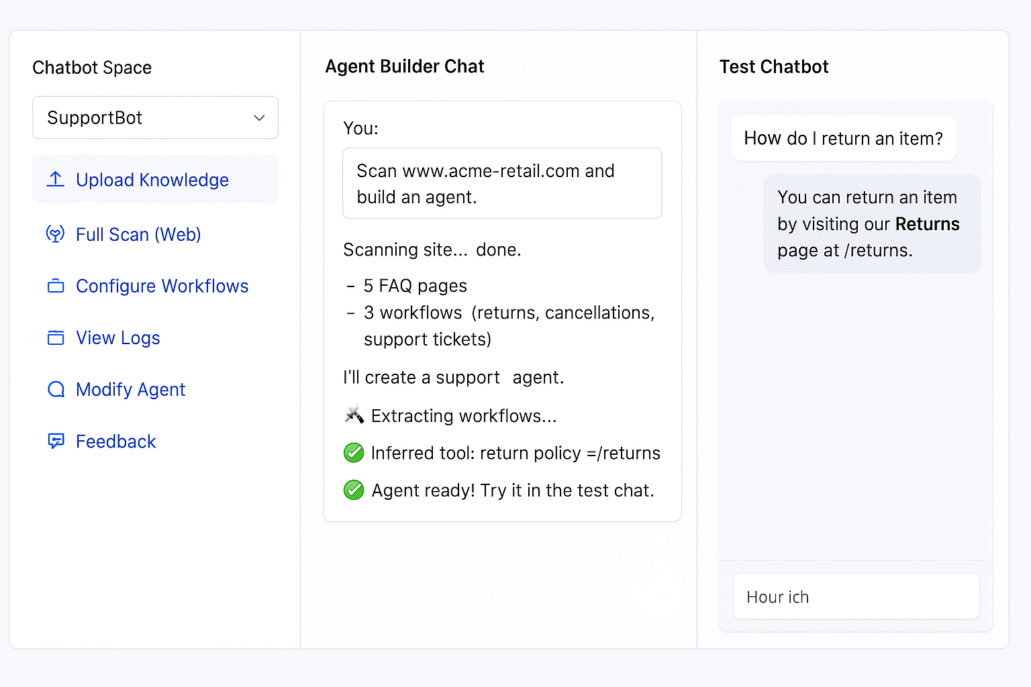

Agent retraining via feedback updates

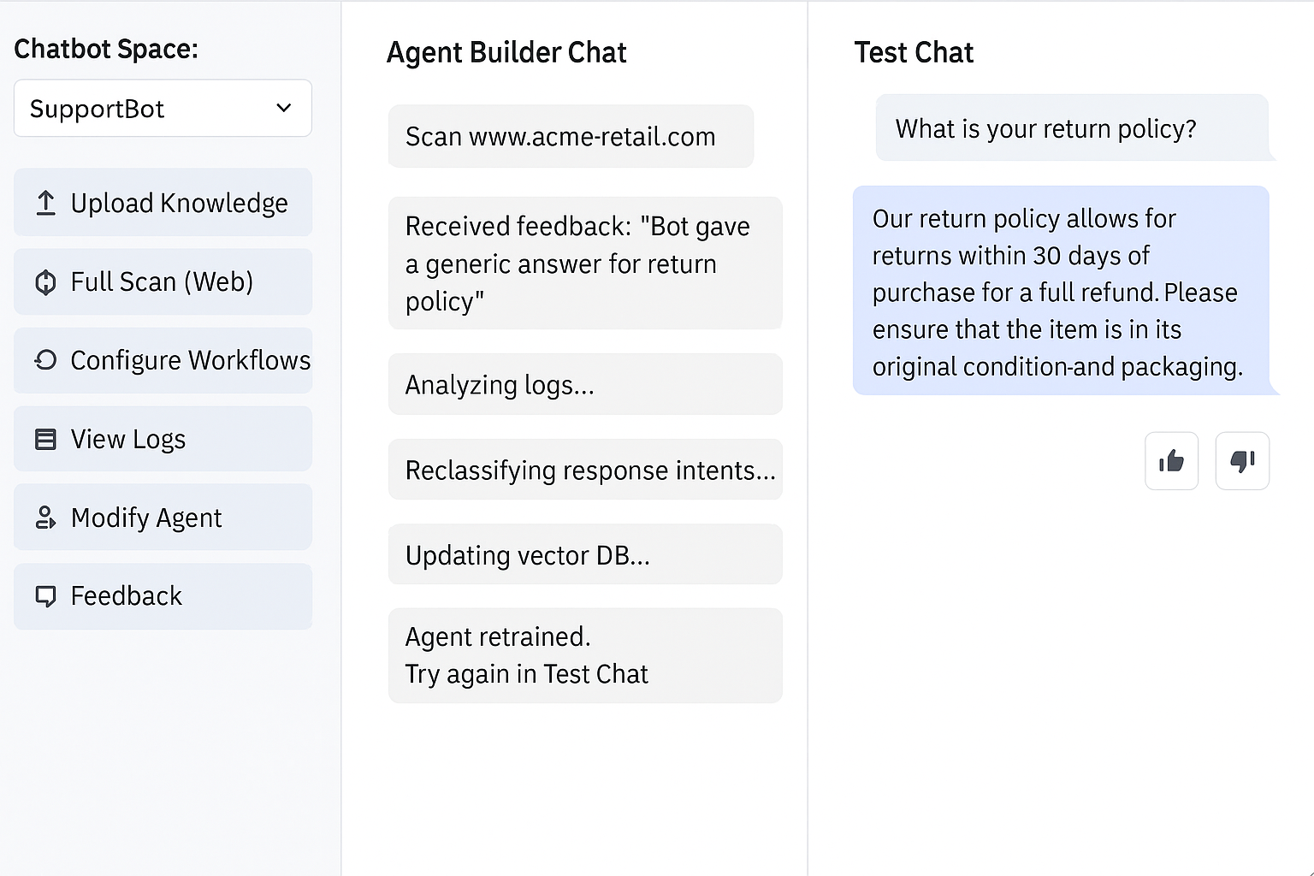

Mock API generator shown in UI

